WEEK 1 – Insurance Database 22/09/2025

Q. Create the above tables by properly specifying the primary keys and the foreign keys. Enter at least five tuples for each relation. Display Accident date and location. Update the damage amount to 25000 for the car with a specific reg_num (example 'K A053408' ) for which the accident report number was 12. Add a new accident to the database.

USE THIS: PERSON (driver_id: String, name: String, address: String)

CAR (reg_num: String, model: String, year: int)

ACCIDENT (report_num: int, accident_date: date, location: String)

OWNS (driver_id: String, reg_num: String)

PARTICIPATED (driver_id: String,reg_num: String, report_num: int, damage_amount: int)

Solution: USE newdatabase01;

create table person (driver_id varchar(10),

name varchar(20), address varchar(30), primary key(driver_id));

create table car(reg_num varchar(10),model varchar(10),year int, primary key(reg_num));

create table accident(report_num int, accident_date date, location

varchar(20),primary key(report_num));

create table owns(driver_id varchar(10),reg_num varchar(10),

primary key(driver_id, reg_num),

foreign key(driver_id) references person(driver_id),

foreign key(reg_num) references car(reg_num));

create table participated(driver_id varchar(10), reg_num varchar(10),

report_num int, damage_amount int,

primary key(driver_id, reg_num, report_num),

foreign key(driver_id) references person(driver_id),

foreign key(reg_num) references car(reg_num),

foreign key(report_num) references accident(report_num));

INSERT into accident values (11, '2003-01-01',"Mysore Road");

INSERT into accident values (12,'2004-02-02',"South end Circle");

insert into accident values (13,'2003-01-21',"Bull temple Road");

insert into accident values (14,'2008-02-17',"Mysore Road");

insert into accident values (15,'2004-03-05',"Kanakpura Road");

Select * from accident;

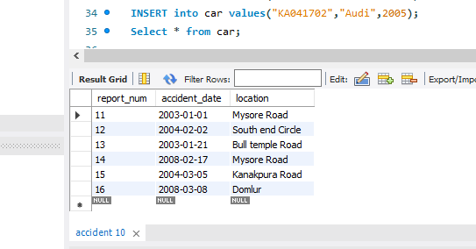

INSERT into car values("KA052250","Indica",1990);

INSERT into car values("KA031181","Lancer",1957);

INSERT into car values("KA095477","Toyota",1998);

INSERT into car values("KA053408","Honda",2008);

INSERT into car values("KA041702","Audi",2005);

Select * from car;

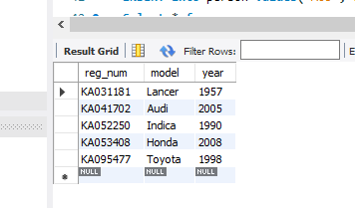

INSERT into person values("A01","Richard","Srinivas nagar");

INSERT into person values("A02","Pradeep","Rajaji nagar");

INSERT into person values("A03","Smith","Ashok nagar");

INSERT into person values("A04","Venu","N R Colony");

INSERT into person values("A05","Jhon","Hanumanth nagar");

Select * from person;

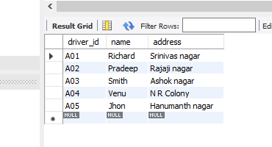

INSERT into owns values("A01","KA052250");

INSERT into owns values("A02","KA053408");

INSERT into owns values("A03","KA031181");

INSERT into owns values("A04","KA095477");

INSERT into owns values("A05","KA041702");

Select * from owns;

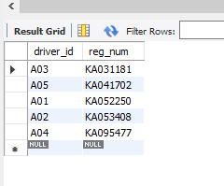

INSERT into participated values("A01","KA052250",11,10000);

INSERT into participated values("A02","KA053408",12,50000);

INSERT into participated values("A03","KA095477",13,25000);

INSERT into participated values("A04","KA031181",14,3000);

INSERT into participated values("A05","KA041702",15,5000);

select * from participated;

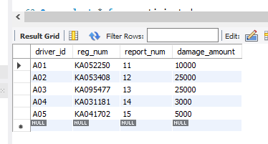

update participated set damage_amount=25000

where reg_num='KA053408' and report_num=12;

select * from participated;



select count(distinct driver_id) CNT

from participated a, accident b

where a.report_num=b.report_num and b.accident_date like '%08%';

insert into accident values(16,"2008-03-08",'Domlur');

select * from accident;

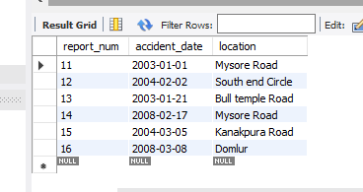

select driver_id from participated where damage_amount>=25000;

